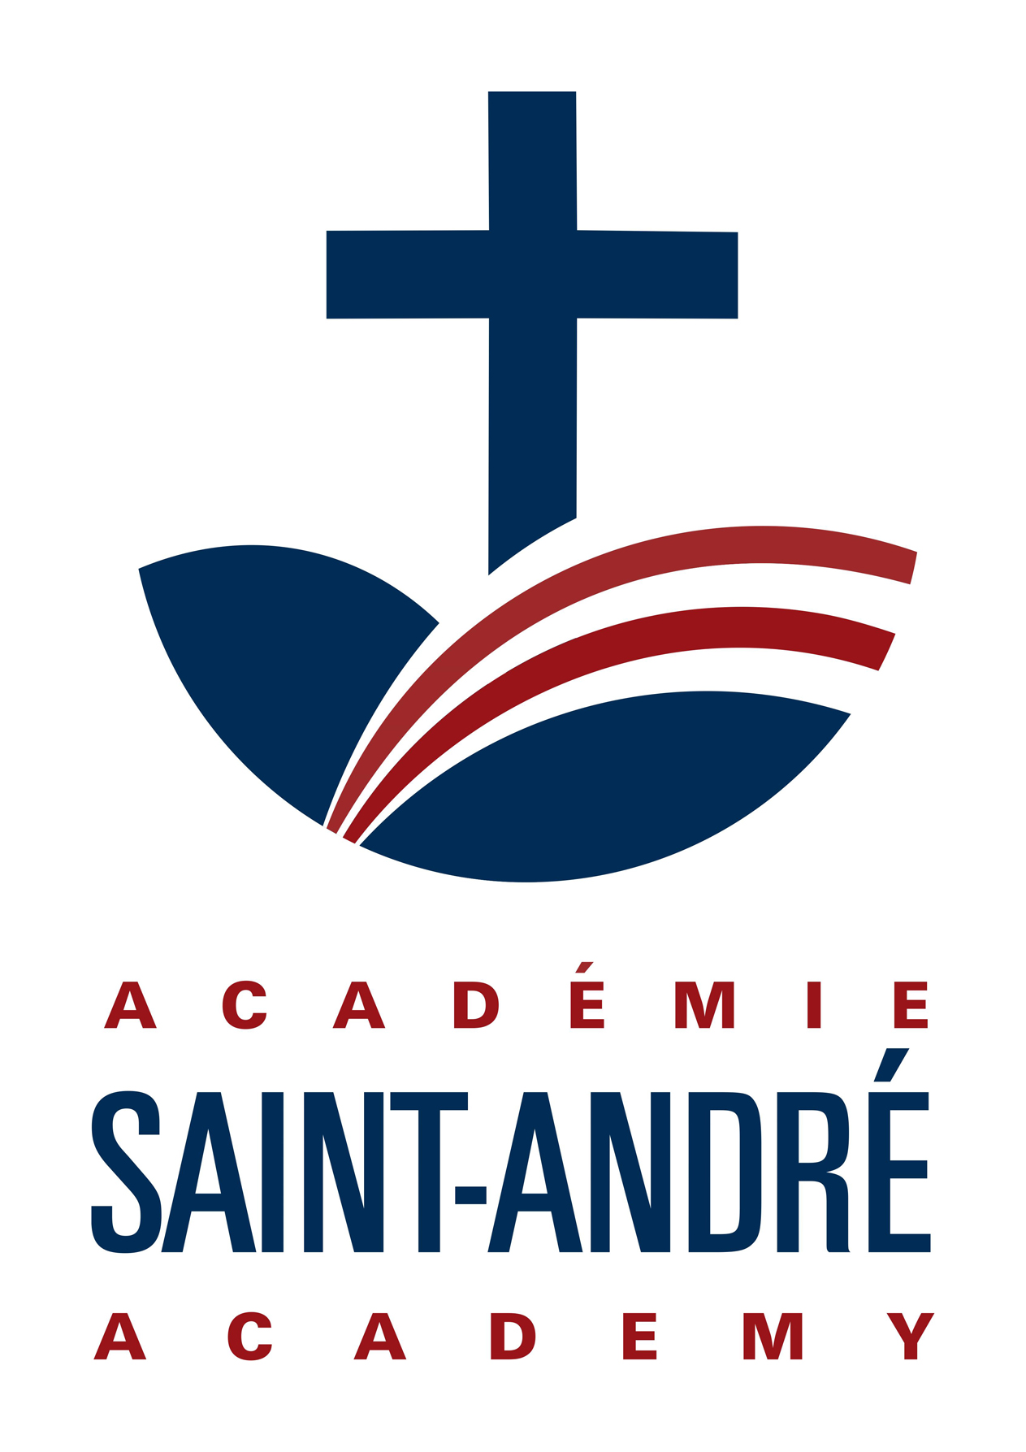

Friends of St. Andre Society

AGENDA

Wednesday May 22, 2024

1.0 CALL TO ORDER

Attendance:

2.0 REVIEW APPROVAL OF AGENDA

3.0 Minutes reviewed from previous meeting

4.0 OLD BUSINESS:

4.1. Bottle Depot

5.0 NEW Business

5.1 Fundraising Ideas -

* Get an early start in September

5.2 Wish List -

6.0 FUND REQUESTS

* Mandy to submit receipts to Lindsay for teach appreciation supples

7.0 UPDATE from Lindsay - Notice of Annual Return

Meeting adjourned:

Upcoming meeting: